**Name: Damion Samuels**

**Assignment 3: SQL**

1. Using the following Link <https://github.com/niteen11/cuny_lagcc_micro_credential_data_analytics/tree/main/Track%20A/Unit%205%20-%20SQL_%20Relational%20Databases/guided%20exercise>

First you have to create a table than upload the data ,safe the table in to your Laptop and change the path accordingly.usr the following link for creating table,

<https://github.com/niteen11/cuny_lagcc_micro_credential_data_analytics/blob/main/Track%20A/Unit%205%20-%20SQL_%20Relational%20Databases/guided%20exercise/student.sql>

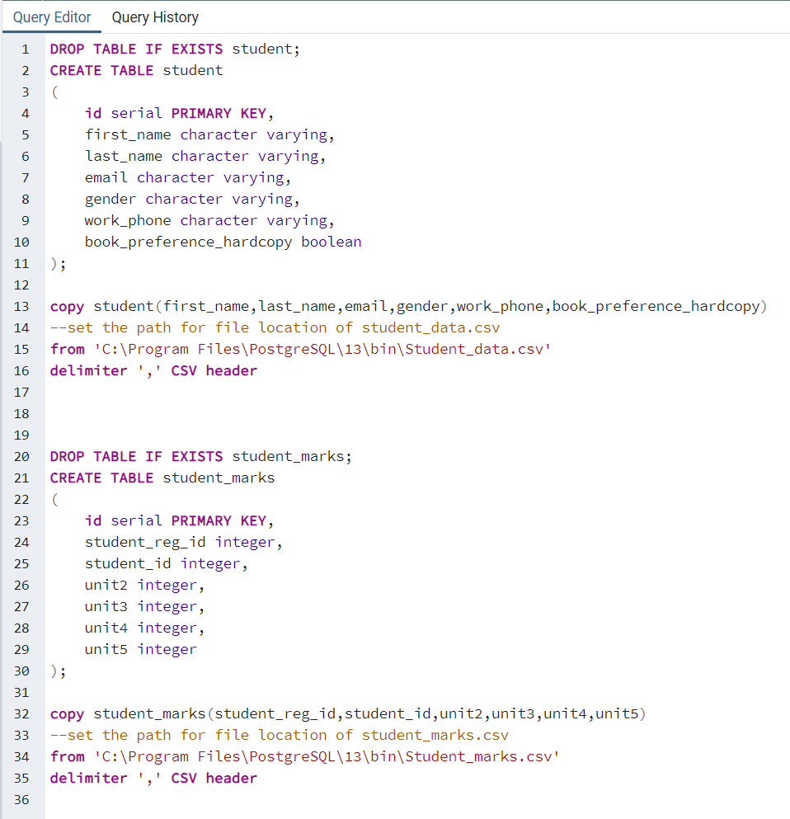

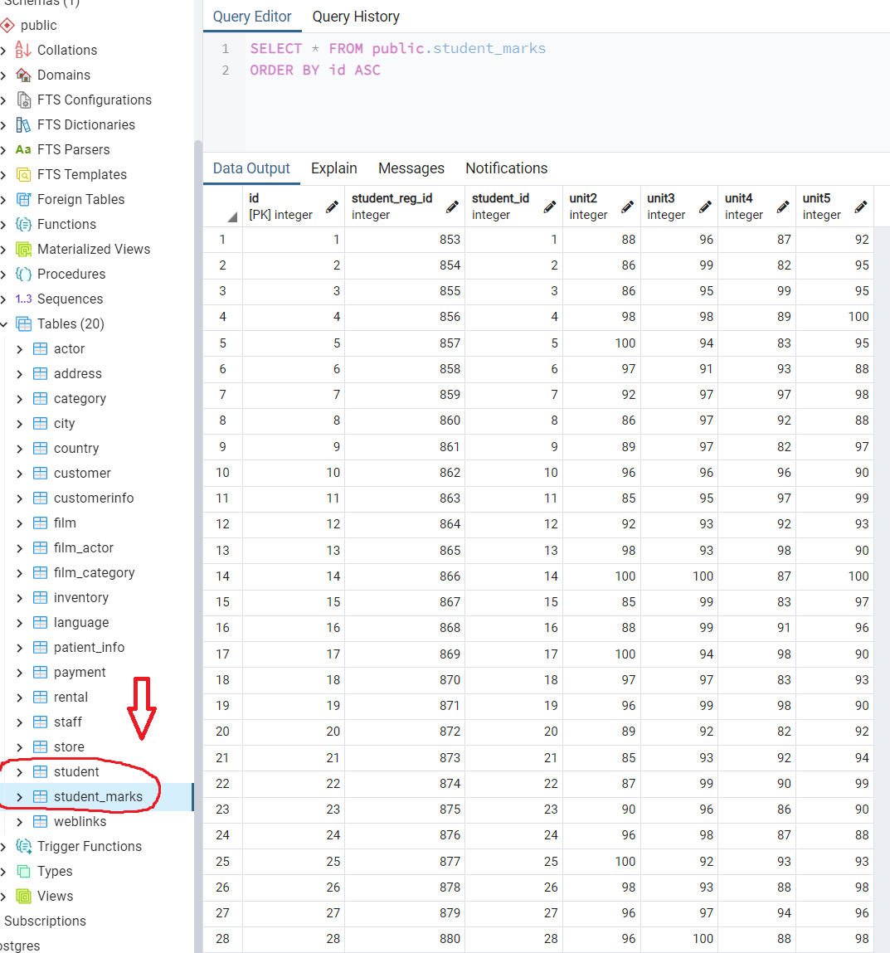

And attached data set (Student_data and Student_marks ) answer the following questions :

1. Students with the highest unit4 marks

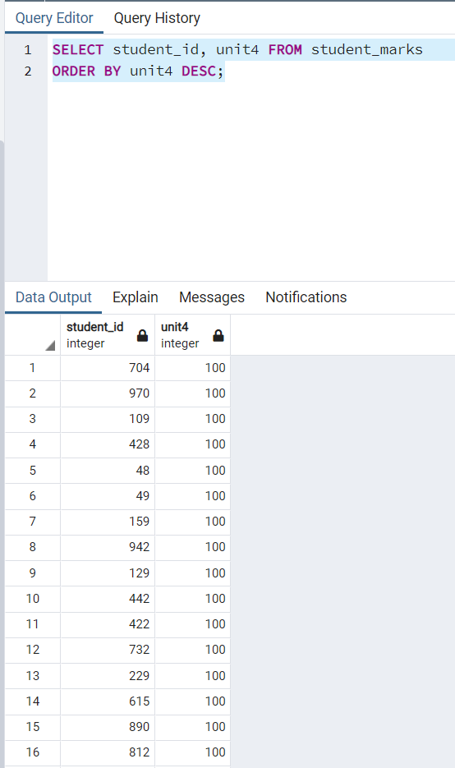

1. Find students scored between 89 and 100 unit4

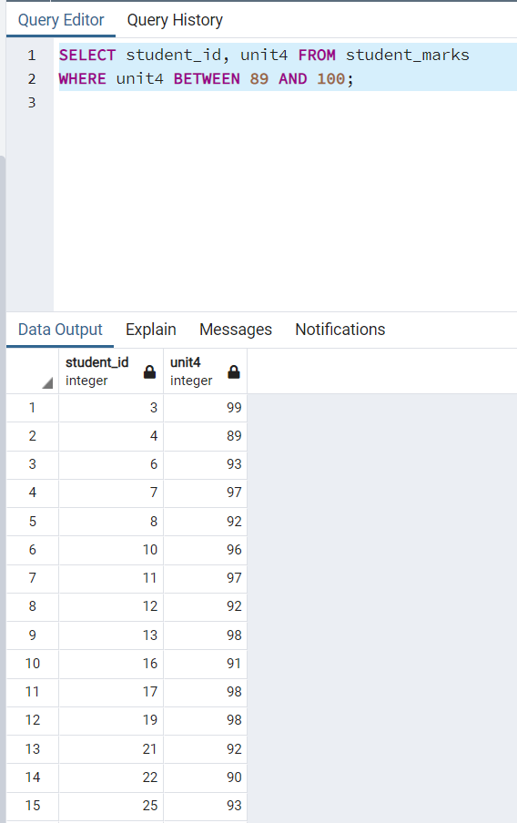

1. **Open ended questions:**

**-- Take a closer look at the tables that you created and come up with 10 different scenarios/ questions and form SQL**

1. Format Student names in alphabetical order by last name.

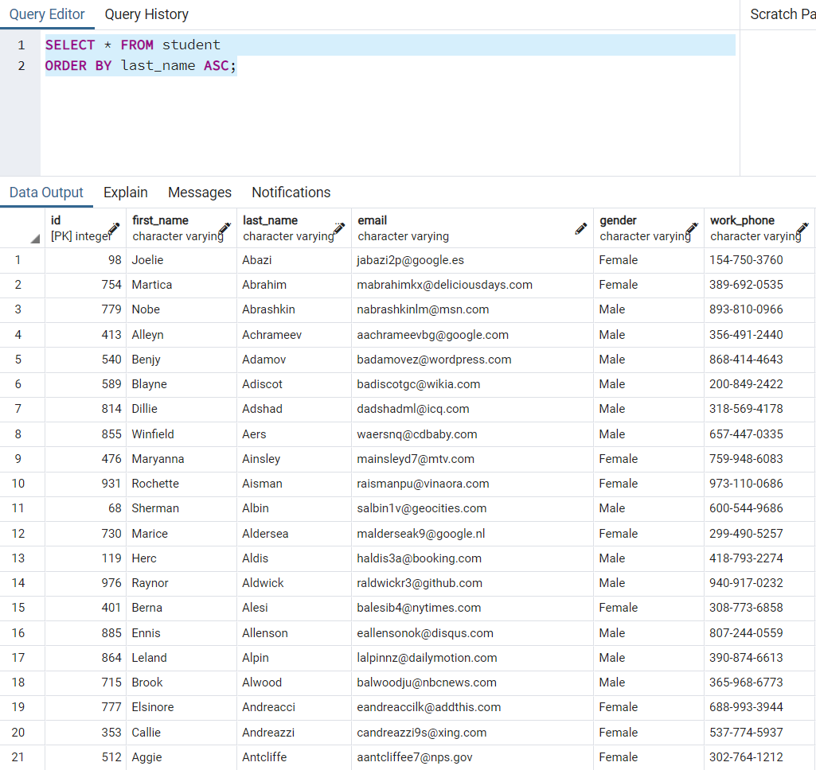

1. Show only male students.

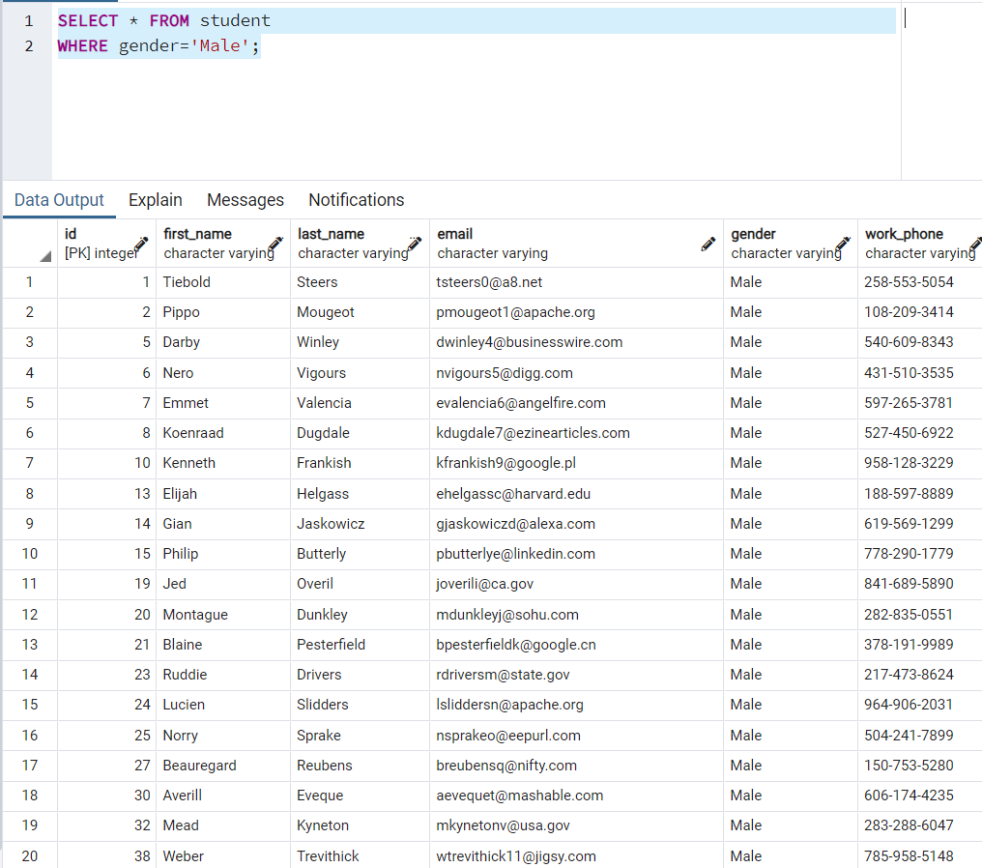

1. Only show students who got score of 100 in Unit2

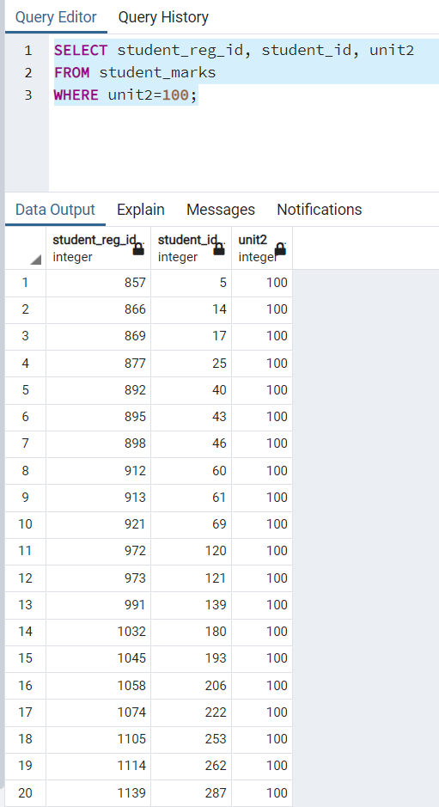

1. Find the average score for Unit 5.

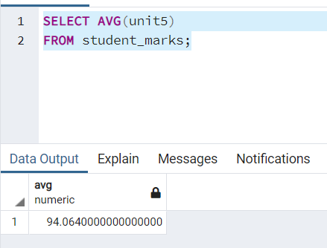

1. How many different integer grades were in Unit 3?

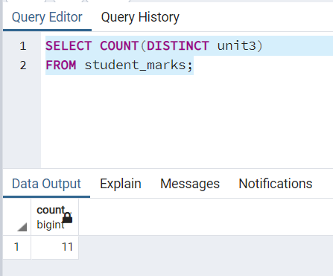

1. Find the work phone for the student whose name is Joelie.

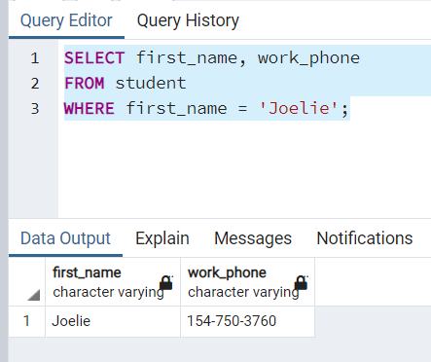

1. Format Unit 3 from highest to lowest for student marks,

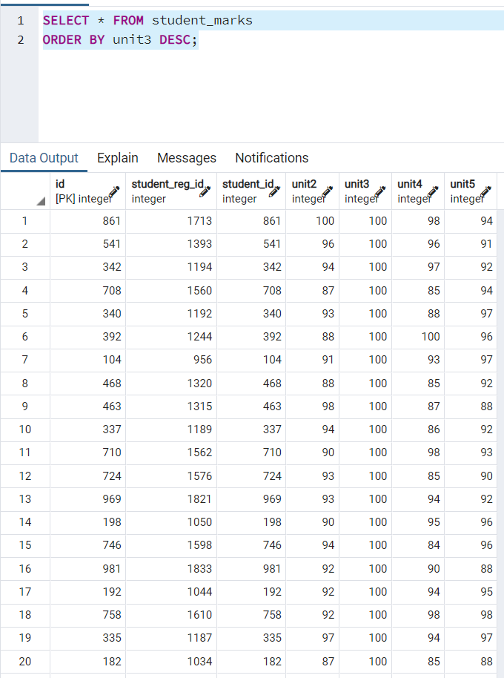

1. Show only female students

